Total slides: 7 (excluding intro & thank you)
- Problem Statement
- Current Scope (PoC)
- Summary
- Recommendations
- Future Scope
- Tech Architecture
Below are my thoughts. Please feel free to add anything that makes more sense that I had below. But I stick with structure..

Problem Statement format examples:
Below are some 2 examples of our past 2 pitches for different problem statement all together. But just giving them for reference.

- Sample Snip 1
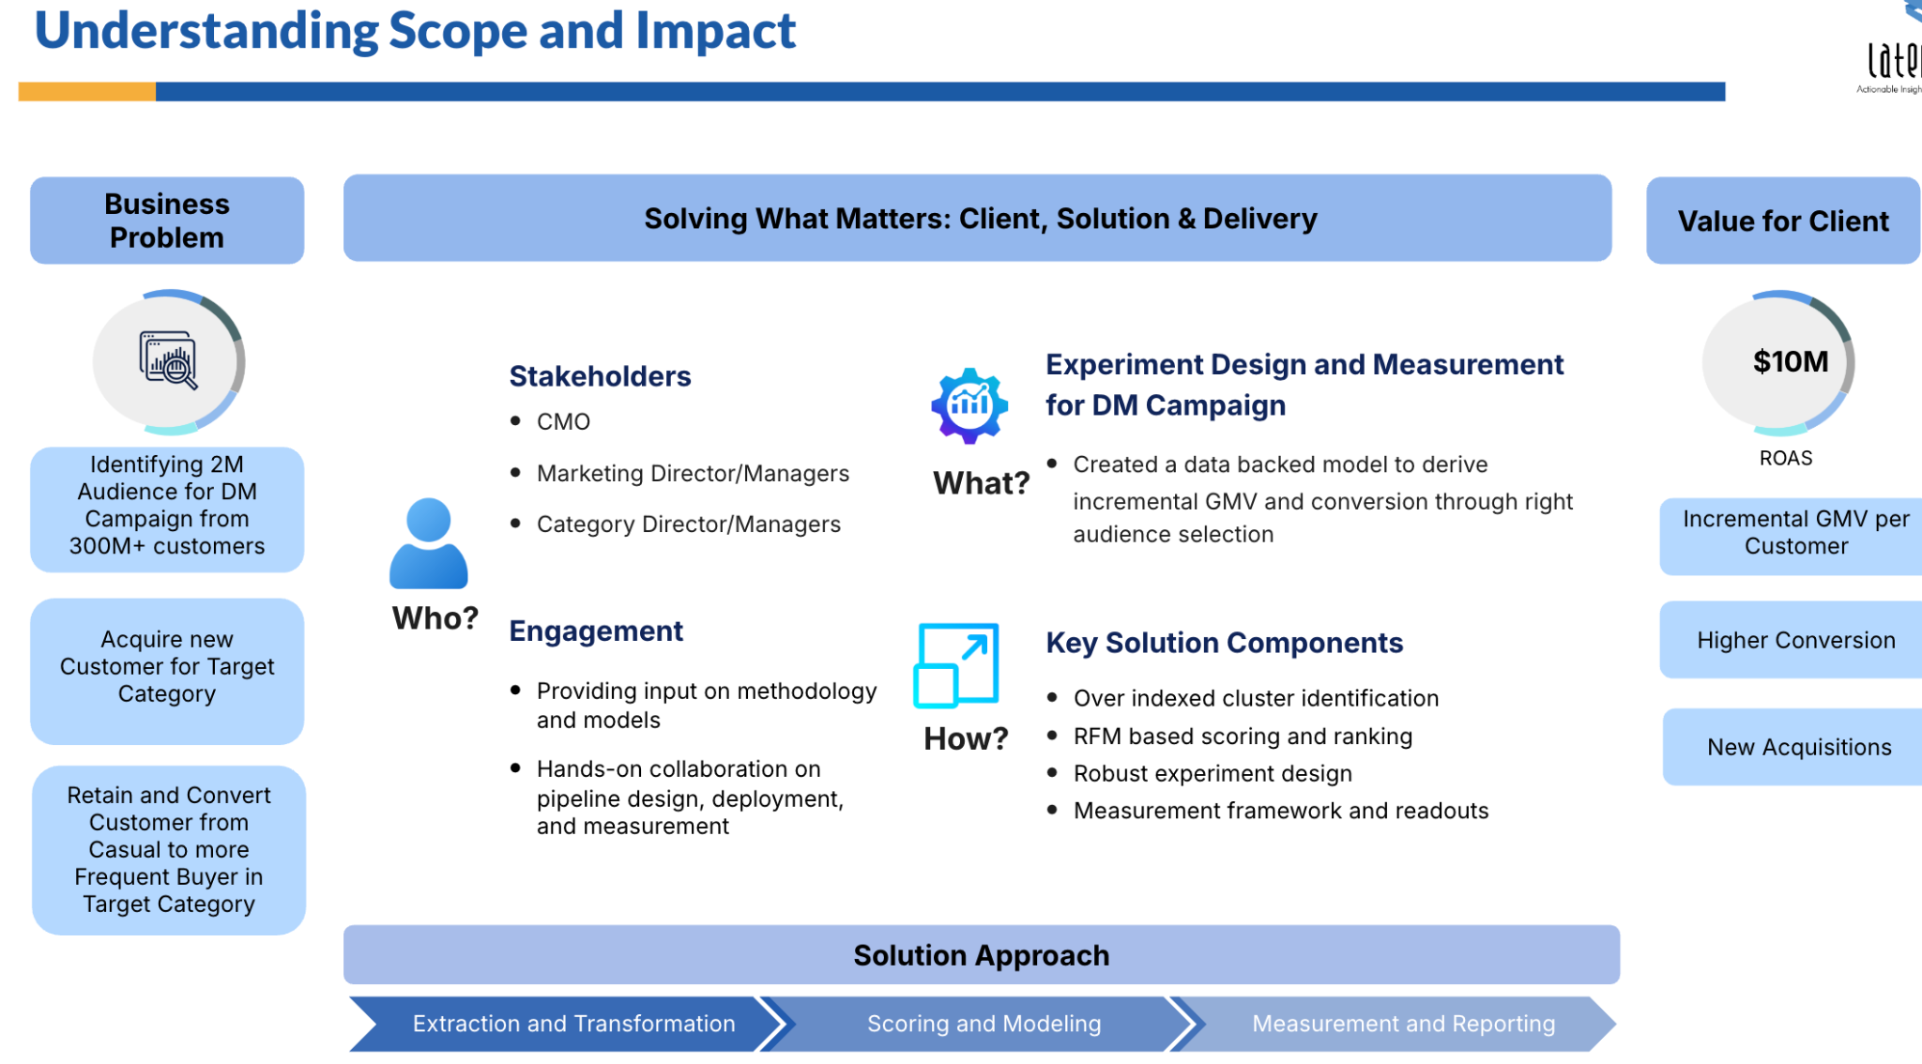

- Sample Snip 2
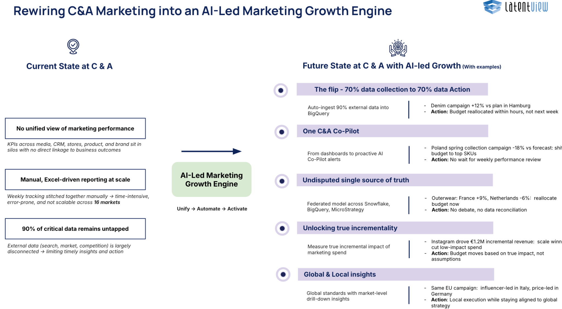

Current Scope (PoC):
- Consider that table of final 12 nodes we had. But out of them, choose only 9. Basicaly choose only top 3 of each segment with best insights and results we have to discuss
- Just add that table 9 rows 3 columns
- In the bottom give the reasonings for segment & competitors chosen
- Also tell them a disclaimer, that data is not fully exhaustive.

Insights:
- Here I want as many insights as possible, I am thinking of 3 columns, Staples, Wayfair & Amazon
- WRT Rows are like advantages, design, what do they deep deeper. best attributes or things we can compare and give them those connecting insights. (Pat should be like yes I agree with all these and infact he should find some insights he might not be aware.)

Recommendations:
- From our analysis we show them them top 2 recommendations of all 9 selected
- Something like in 3*3 matrix (segments in columns hero, probable, non) and in rows (the top 1, 2 & 3 chosen category)
- And in each cell we show our best 2 recommendations hyperlinked to respective amazon/wayfair

Future Scope:
- There will be 2 sections here, like ONE: what more we can do if we have internal data. TWO: apart from this recommendation, what else can we do?
- For example for first one: internal data
  - We can do Customer Profiling, Demand analysis and then target the Accurate & Right Segments (Hero, Prob & Non Hero)
  - Vendor Catalog Filtering: We can use the same framework and pivot the same recommendation engine and apply on the seller listings and vet or approve for entering the site. -

- For example for Second One:
  - Website Search Intent and Internal Data Integration: Utilizing internal website search data to identify high-demand items that currently lack search results or listings (planned as a future proof-of-concept scope)
  - Demand Forecasting and Market Research: Adding value-add services such as social media analysis or market research for non-hero explore categories to increase deal size value
  - Something along the lines of Baskets. Maybe like Market basket analysis, with Transactional data, we can find something missing in the catalog that completes the basket.

Tech Architecture:
- This is where our entire methodology comes in a simple diagram.
- Sample snip below
